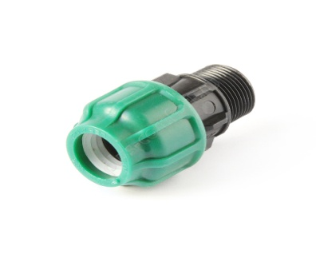
Муфта с наружной резьбой POELSAN
ДхДу  ммхдюйм | Шт.  (уп/кор) | Цена розн. | Цена опт.
20 х 1/2" | 50/1000 | 17,46 | 13,86
20 х 3/4" | 50/900 | 17,60 | 13,98
25x1/2" | 25/650 | 21,59 | 17,15
25 х 3/4" | 25/650 | 21,74 | 17,27
25 х 1" | 25/600 | 22,63 | 17,97
32×1/2ˮ | 25/400 | 30,18 | 23,96
32 х 3/4" | 25/400 | 30,33 | 24,08
32 х 1" | 25/375 | 31,06 | 24,66
32x1 1/4" | 25/350 | 32,69 | 25,96
40 х 1 " | 15/210 | 49,56 | 39,35
40 х 1 1/4" | 15/210 | 50,73 | 40,29
40 х 1 1/2" | 15/210 | 51,32 | 40,76
50 х 1 1/4" | 10/130 | 77,35 | 61,43
50 х 1 1/2" | 10/130 | 77,50 | 61,54
50 х 2" | 10/130 | 79,27 | 62,95
63 х 1 1/2" | 6/96 | 104,72 | 83,15
63 х 2" | 6/96 | 106,20 | 84,33
63 х 2 1/2" | 6/84 | 108,56 | 86,21
75 X 2" | 4/52 | 187,10 | 148,57
75x2 1/2" | 4/48 | 188,12 | 149,40
75 х 3" | 4/48 | 190,35 | 151,16
90x2 1/2" | 4/32 | 271,25 | 215,40
90x 3" | 4/32 | 272,29 | 216,23
90x 4" | 4/32 | 272,58 | 216,46
110x3" | 2/18 | 425,22 | 337,67
110x4" | 2/18 | 425,22 | 337,67

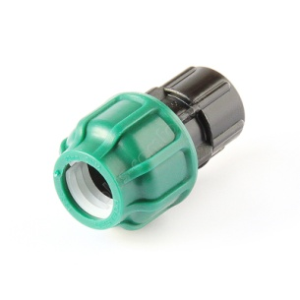
Муфта с внутренней резьбой POELSAN
ДхДу  ммхдюйм | Шт (уп/кор) | Цена  розн. | Цена опт.
20x1/2" | 50/900 | 20,71 | 16,44
20x3/4" | 50/800 | 21,45 | 17,03
25x1/2" | 25/600 | 24,85 | 19,73
25x3/4" | 25/600 | 25,14 | 19,97
25x1" | 25/475 | 27,51 | 21,85
32x3/4" | 25/350 | 35,05 | 27,84
32x1" | 25/350 | 35,50 | 28,19
32x1 1/4" | 25/275 | 38,17 | 30,30
40x1 | 15/210 | 54,57 | 43,34
40x1 1/4 | 15/195 | 56,80 | 45,10
40x1 1/2" | 15/165 | 62,12 | 49,33
50x1 1/4" | 10/130 | 79,27 | 62,95
50x1 1/2" | 10/130 | 80,46 | 63,89
50x2" | 10/100 | 85,05 | 67,53
63x1 1/2" | 6/84 | 111,21 | 88,32
63x2" | 6/84 | 113,44 | 90,08
63x2 1/2" | 6/84 | 122,47 | 97,25
75x2" | 4/48 | 196,55 | 156,09
75x2 1/2" | 4/48 | 201,59 | 160,08
75x3" | 4/48 | 211,94 | 168,31
90x2 1/2" | 4/32 | 284,56 | 225,97
90x3" | 4/32 | 287,37 | 228,21
90x4" | 4/32 | 302,75 | 240,42
110x3" | 2/18 | 438,38 | 348,12
110x4" | 2/18 | 441,63 | 350,71

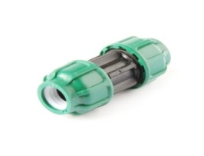
Муфта соединительная POELSAN
ДхД  ммхмм | Шт. (уп/кор) | Цена розн. | Цена опт.
20x20 | 25/550 | 31,35 | 24,90
25x25 | 25/375 | 37,86 | 30,06
32x32 | 10/240 | 54,28 | 43,11
40x40 | 10/140 | 89,78 | 71,29
50x50 | 6/84 | 128,96 | 102,41
63x63 | 5/50 | 182,07 | 144,59
75x75 | 2/28 | 327,30 | 259,92
90x90 | 2/16 | 479,04 | 380,42
110x110 | 1/10 | 753,85 | 598,64
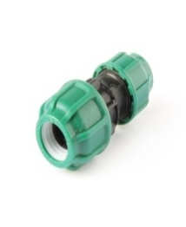
Муфта переходная POELSAN
ДхД  ммхмм | Шт. (уп/кор) | Цена розн. | Цена опт.
25x20 | 25/400 | 35,64 | 28,31
32x20 | 10/280 | 45,41 | 36,06
32х25 | 10/260 | 48,36 | 38,41
40х20 | 10/180 | 62,12 | 49,33
40x25 | 10/160 | 65,67 | 52,15
40x32 | 10/160 | 73,06 | 58,02
50х25 | 6/120 | 91,55 | 72,70
50x32 | 6/114 | 98,06 | 77,87
50x40 | 6/96 | 112,00 | 89,73
63х32 | 6/78 | 125,27 | 99,48
63x40 | 6/78 | 140,95 | 111,93
63x50 | 6/72 | 157,66 | 125,20
75x50 | 2/36 | 241,82 | 192,03
75х63 | 2/36 | 261,19 | 207,42
90х63 | 2/24 | 344,46 | 273,54
90х75 | 2/24 | 407,32 | 323,46
110х75 | 1/14 | 565,42 | 449,01
110х90 | 1/12 | 628,84 | 498,58
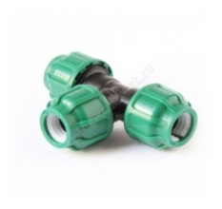
Тройник равносторонний POELSAN
ДхДхД  ммхммхмм | Шт. (уп/кор) | Цена розн. | Цена опт.
20x20x20 | 15/300 | 47,77 | 37,94
25x25x25 | 10/200 | 61,23 | 48,62
32x32x32 | 5/120 | 87,86 | 69,77
40x40x40 | 5/70 | 144,21 | 114,51
50x50x50 | 4/48 | 208,69 | 165,72
63x63x63 | 3/27 | 303,79 | 241,24
75x75x75 | 1/16 | 526,08 | 417,77
90x90x90 | 1/9 | 774,40 | 614,97
110x110x110 | 1/5 | 1198,43 | 951,70
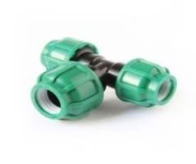
Тройник переходной POELSAN
ДхДхД  ммхммхмм | Шт. (уп/кор) | Цена розн. | Цена опт.
20х25х20 | 10/260 | 55,47 | 44,04
25x20x25 | 10/220 | 59,31 | 47,10
25х32х25 | 10/160 | 72,47 | 57,55
32x20x32 | 5/150 | 76,61 | 60,84
32x25x32 | 5/140 | 80,01 | 63,54
40x25x40 | 5/95 | 116,69 | 92,67
40x32x40 | 5/80 | 127,49 | 101,24
50х25х50 | 4/64 | 156,77 | 124,50
50x32x50 | 4/56 | 165,80 | 131,66
50x40x50 | 4/48 | 184,58 | 146,58
63х32х63 | 3/42 | 220,96 | 175,47
63x40x63 | 3/36 | 240,78 | 191,21
63x50x63 | 3/30 | 266,22 | 211,41
75x50x75 | 1/23 | 428,02 | 339,90
75x63x75 | 1/19 | 533,38 | 361,28
90x63x90 | 1/13 | 629,76 | 500,10
90x75x90 | 1/11 | 707,11 | 561,53
110x90x110 | 1/6 | 1066,51 | 846,93
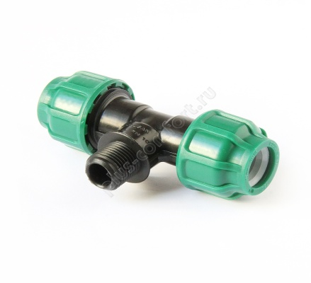
Тройник с наружной резьбой POELSAN
ДхДухД ммхдюймхмм | Шт. (уп/кор) | Цена розн. | Цена опт.
20x1/2"x20 | 15/405 | 41,26 | 32,77
20x3/4"x20 | 15/390 | 41,26 | 32,77
25x1/2"x25 | 10/300 | 49,84 | 39,58
25x3/4"x25 | 10/280 | 49,84 | 39,58
25x1"x25 | 10/240 | 49,84 | 39,58
25*1 1/4*25 | 10/220 | 55,17 | 43,81
32x3/4"x32 | 10/170 | 65,67 | 52,15
32x1"x32 | 10/160 | 67,44 | 53,56
32*1 1/4*32 | 10/150 | 73,80 | 58,61
40x1"x40 | 5/100 | 106,49 | 84,56
40x1 1/4"x40 | 5/90 | 110,77 | 87,97
40*1 1/2*40 | 5/80 | 117,44 | 93,26
50x1"x50 | 4/68 | 144,06 | 114,40
50x1 1/4"x50 | 4/64 | 149,09 | 118,39
50x1 1/2"x50 | 4/64 | 156,18 | 124,03
50х2х50 | 4/52 | 163,13 | 129,55
63x1 1/4"x63 | 3/45 | 203,81 | 161,85
63x1 1/2"x63 | 3/39 | 209,13 | 166,07
63x2"x63 | 3/36 | 220,08 | 174,77
63х2 1/2х63 | 3/33 | 229,69 | 182,40
75x2"x75 | 1/24 | 381,29 | 302,79
75x21/2"x75 | 1/23 | 390,75 | 310,30
75х3х75 | 1/20 | 406,13 | 322,52
90x21/2"x90 | 1/14 | 533,77 | 423,88
90x3"x90 | 1/14 | 582,13 | 462,28
90х4"х90 | 1/13 | 597,52 | 474,50
110x3"x110 | 1/8 | 925,70 | 735,12
110x4"x110 | 1/8 | 925,70 | 735,12
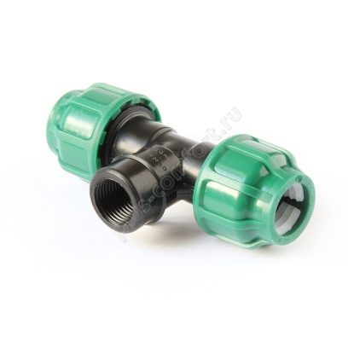
Тройник с внутренней резьбой POELSAN
ДхДухД ммхдюймхмм | Шт. (уп/кор) | Цена розн. | Цена опт.
20x1/2"x20 | 15/405 | 43,63 | 34,65
20x3/4"x20 | 15/360 | 46,89 | 37,23
25x1/2"x25 | 10/280 | 52,21 | 41,46
25x3/4"x25 | 10/260 | 53,09 | 42,16
25x1"x25 | 10/240 | 58,43 | 46,39
32x1/2"x32 | 10/170 | 72,32 | 57,43
32x3/4"x32 | 10/170 | 72,32 | 57,43
32x1"x32 | 10/160 | 75,43 | 59,90
32x1 1/4"x32 | 10/140 | 81,63 | 64,83
40x3/4"x40 | 5/110 | 109,89 | 87,27
40x1"x40 | 5/100 | 112,56 | 89,38
40x11/4"x40 | 5/90 | 117,13 | 93,02
40x11/2"x40 | 5/80 | 127,64 | 101,36
50x3/4"x50 | 4/64 | 147,17 | 116,86
50x1"x50 | 4/64 | 149,97 | 119,09
50x11/4"x50 | 4/64 | 154,41 | 122,62
50x11/2"x50 | 4/64 | 165,21 | 131,19
50x2"x50 | 4/48 | 181,63 | 144,23
63x1"x63 | 3/42 | 208,54 | 165,60
63x11/4"x63 | 3/39 | 210,61 | 167,25
63x1 1/2"x63 | 3/39 | 221,41 | 175,82
63x2"x63 | 3/36 | 252,62 | 200,60
63x2 1/2"x63 | 3/33 | 252,62 | 200,60
75x2"x75 | 1/24 | 401,10 | 318,52
75x21/2"x75 | 1/23 | 409,84 | 325,45
75x3"x75 | 1/18 | 429,06 | 340,72
90x21/2"x90 | 1/14 | 588,93 | 467,68
90x3"x90 | 1/14 | 610,83 | 485,07
90x4"x90 | 1/12 | 631,38 | 501,39
110x3"x110 | 1/8 | 906,03 | 719,50
110x4"x110 | 1/8 | 928,08 | 737,00

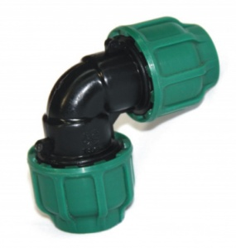
Отвод 90градусов POELSAN
ДхД  ммхмм | Шт. (уп/кор) | Цена розн. | Цена опт.
20х20 | 25/500 | 30,33 | 24,08
25x25 | 15/300 | 38,17 | 30,30
32x32 | 10/200 | 57,39 | 45,57
40x40 | 5/110 | 95,85 | 81,75
50х50 | 4/68 | 138,74 | 110,17
63х63 | 4/44 | 196,71 | 156,21
75x75 | 2/24 | 366,50 | 291,04
90x90 | 2/16 | 533,77 | 423,88
110x110 | 1/8 | 838,59 | 665,94

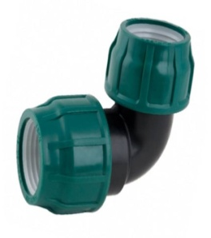

Отвод переходной POELSAN
ДхД  ммхмм | Шт. (уп/кор) | Цена розн. | Цена опт.
25x20 | 15/390 | 36,38 | 28,89
32х25 | 10/220 | 49,40 | 39,23
40x32 | 5/140 | 79,13 | 62,84
50x40 | 4/80 | 118,02 | 93,73
63x50 | 4/48 | 167,87 | 133,31
75х63 | 2/32 | 311,33 | 247,23
90х75 | 1/20 | 486,59 | 386,41
110х90 | 1/12 | 694,09 | 551,19

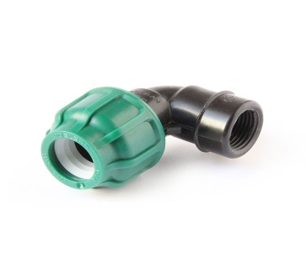
Отвод с внутренней резьбой POELSAN
ДхДу  ммхдюйм | Шт. (уп/кор) | Цена розн. | Цена опт.
20x1/2" | 25/700 | 24,85 | 19,73
20x3/4" | 25/600 | 27,51 | 21,85
25x1/2" | 15/510 | 29,29 | 23,26
25x3/4" | 15/480 | 29,87 | 23,72
25x1" | 15/390 | 34,61 | 27,48
32x3/4" | 10/340 | 39,49 | 31,36
32x1" | 10/280 | 44,22 | 35,12
32x1 1/4" | 10/220 | 50,58 | 40,17
40x1" | 5/180 | 63,89 | 50,74
40x11/4" | 5/170 | 68,32 | 54,26
40x11/2" | 5/150 | 74,70 | 59,31
50x11/4" | 4/108 | 90,51 | 71,88
50х11/2" | 4/108 | 96,42 | 76,58
50х2" | 4/80 | 107,08 | 85,03
63*11/2 | 4/64 | 126,75 | 100,65
63x2" | 4/64 | 138,58 | 110,05
63x2 1/2" | 4/52 | 151,01 | 119,92
75x2" | 2/40 | 253,97 | 201,66
75x21/2" | 2/36 | 256,75 | 203,89
75x3" | 2/32 | 268,58 | 213,29
90x21/2" | 1/28 | 352,75 | 280,12
90x3" | 1/26 | 370,19 | 293,98
90x4" | 1/20 | 390,75 | 310,30
110x3" | 1/15 | 526,37 | 418,00
110x4" | 1/14 | 552,86 | 439,03

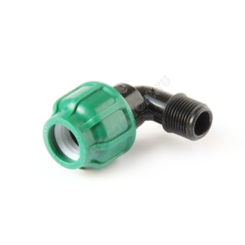

Отвод с наружной резьбой POELSAN
ДхДу  ммхдюйм | Шт. (уп/кор) | Цена розн. | Цена опт.
20x1/2" | 25/800 | 19,98 | 15,86
20x3/4" | 25/700 | 21,90 | 17,38
25x1/2" | 15/510 | 26,33 | 20,91
25x3/4" | 15/510 | 26,33 | 20,91
25x1" | 15/450 | 27,95 | 22,20
32x3/4" | 10/320 | 37,72 | 29,95
32x1" | 10/320 | 37,72 | 29,95
32x11/4" | 10/260 | 42,16 | 33,47
40x1" | 5/180 | 61,83 | 49,09
40x11/4" | 5/180 | 61,83 | 49,09
40x11/2" | 5/180 | 66,11 | 52,50
50x11/4" | 4/108 | 89,93 | 71,41
50x11/2" | 4/108 | 89,93 | 71,41
50х2" | 4/100 | 93,77 | 74,46
63x11/2" | 4/64 | 127,79 | 101,48
63x2" | 4/64 | 127,79 | 101,48
63х21/2 | 4/64 | 132,07 | 104,88
75x2" | 2/36 | 253,95 | 201,66
75x21/2" | 2/36 | 253,95 | 201,66
75х3" | 2/32 | 253,95 | 201,66
90x2 1/2" | 1/27 | 351,71 | 279,30
90x3" | 1/26 | 351,71 | 279,30
90x4" | 1/22 | 351,71 | 279,30
110x3" | 1/15 | 550,04 | 436,80
110x4" | 1/15 | 550,04 | 436,80

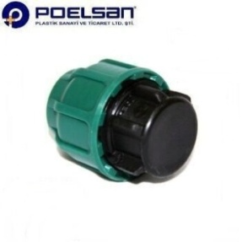
Заглушка POELSAN
Д, мм | Шт. (уп/кор) | Цена розн. | Цена опт.
20 | 50/1100 | 16,86 | 13,39
25 | 25/700 | 21,00 | 16,68
32 | 25/400 | 30,32 | 24,08
40 | 15/240 | 49,40 | 39,23
50 | 12/144 | 77,65 | 61,66
63 | 6/90 | 106,49 | 84,56
75 | 4/60 | 186,95 | 148,46
90 | 4/32 | 271,84 | 215,87
110 | 2/20 | 421,07 | 334,38
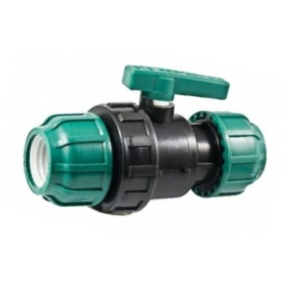
Кран шаровой муфта х муфта Poelsan
Дхвн.р | Шт. (уп/кор) | Цена розн. | Цена опт
40х40 | 60 | 272,58 | 216,46
50х50 | 36 | 370,50 | 294,22
63х63 | 24 | 522,58 | 414,83
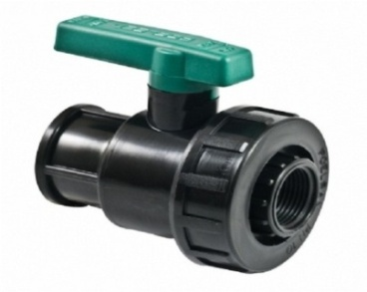
Кран шаровый вн.р х вн.р POELSAN
В.Р х В.Р | Шт. (уп/кор) | Цена розн. | Цена опт.
3/4" x 3/4" | 220 | 115,65 | 91,85

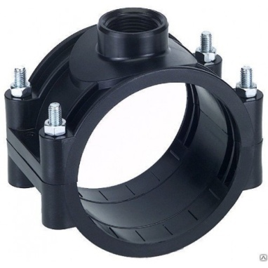

Седловая врезка на болтах POELSAN
ДхДу ммхдюйм | Шт. (уп/кор) | Цена розн. | Цена опт.
25х ½" | 325 | 36,53 | 29,01
40x ½" | 200 | 42,45 | 33,71
40x3/4" | 200 | 43,18 | 34,29
50x ½" | 160 | 50,29 | 39,93
50x3/4" | 160 | 50,58 | 40,16
50x1" | 150 | 51,48 | 40,88
63x ½" | 100 | 81,06 | 64,37
63x3/4" | 100 | 81,63 | 64,83
63x1" | 100 | 82,23 | 65,30
63х1 ¼" | 70 | 96,58 | 76,69
63x1½" | 70 | 98,50 | 78,22
75x½" | 80 | 91,41 | 72,59
75x3/4" | 80 | 91,41 | 72,59
75х1 ¼" | 50 | 114,33 | 90,79
75х1½" | 50 | 115,07 | 91,38
75х2" | 45 | 119,80 | 95,13
110x½" | 50 | 119,95 | 95,26
110x3/4" | 50 | 121,13 | 96,19
110x1" | 45 | 123,20 | 97,85
110x1 ¼" | 40 | 155,14 | 123,20
110x1 ½" | 40 | 157,22 | 124,85
110x2" | 30 | 159,29 | 126,50
125x3/4" | 44 | 143,91 | 114,28
125x1" | 44 | 144,50 | 114,75
125x1 ¼" | 40 | 147,17 | 116,87
125x1 ½" | 40 | 151,74 | 120,50
125x2" | 40 | 153,53 | 121,92
160x3/4" | 16 | 318,58 | 252,99
160x1" | 16 | 322,42 | 256,04
160x1 ¼" | 16 | 322,42 | 256,04
160x2" | 16 | 322,58 | 257,16
200х3/4" | 10 | 404,80 | 321,46
200х1 | 10 | 405,40 | 321,93
200х1 ¼" | 10 | 408,05 | 324,04
200х1½" | 10 | 408,49 | 324,39
200х2 | 10 | 408,95 | 324,76
225х1" | 6 | 630,34 | 500,57
225х1 ¼" | 6 | 638,64 | 507,15
225х1 ½ | 6 | 638,64 | 507,15
225х2" | 6 | 638,64 | 507,15

